**Finch, Robert (Duer Claydon) (1900 – 1995)**

Molly Hall, University of Rhode Island

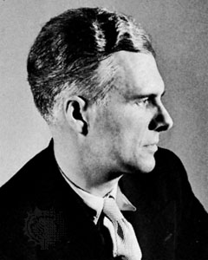**Robert Finch, in profile.**

(url: http://www.britannica.com/biography/Robert-Finch)

Canadian poet, editor, and critic Robert Finch was born on May 14, 1900 in Long Island, New York, but immigrated to Canada, adopting it as his homeland. Like most Canadian modernist poets his most important work was written in the 1930s because of the publication delays due to the Depression. His work was included in several seminal Canadian collections of the mid-century, including *New Provinces: Poems of Several Authors* (1936) and *The Book of Canadian Poetry* (1943), signaling that he had “arrived” as a poetic intellectual. After attaining national recognition, he published his first book, *Poems* (1946), earning him Canada’s highest literary honour, the Governor General’s Award, which he won again with *Acis in Oxford and Other Poems* (1961). Although he wrote in English, his scholarly specialty was French language and poetry, which he studied at the University of Toronto and at the Sorbonne. He was a professor of French at the University of Toronto for forty years from 1928-1968. During his time as a professor, he composed, amongst other things, the collection *Dover Beach Revisited* (1961) concerning World War II and faith through his rewriting of the namesake poem of this collection—Matthew Arnold’s “Dover Beach”—almost a dozen different ways.

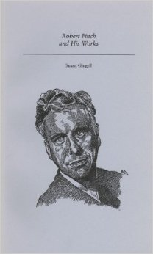**Etched Cover, Finch, Canadian Author Study Series**

(url: http://ecx.images-amazon.com/images/I/

41eZEsh3CyL._SY344_BO1,204,203,200_.jpg)

Some have compared his work to the dandyism tradition amongst British modernists, such as Edith Sitwell and John Betjeman, who wrote in the 1920s and 1930s, but can hardly be considered predecessors. Finch’s work is more formally controlled and less emotionally abundant than his peers, but this subtlety and pointedness actually lends affective force to his verse. His kinship with the dandy style is unique amongst Canadian modernists. The dandy poet observes the decline of the aesthetic pleasures of the old world, material and experiential, with an ironic distance, both mourning their loss and criticizing the fading aristocratic class and their love of fine things—music, clothes, gardens, food, architecture, conversation. For example, his work, *Acis in Oxford*, is based on his meditation on the work of classical composer George Frideric Handel.

[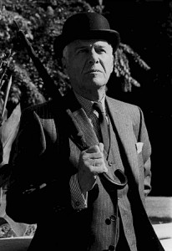](http://porcupinesquill.ca/blog/wp-content/uploads/2010/08/robtfin.jpg)**Robert Finch, by Don McLeod**

(url: http://porcupinesquill.ca/blog/wp-content/uploads/

2010/08/robtfin.jpg)

A persistent trope of his work was flowers, surfacing time and again as symbols for finer emotions and other gentle fleeting social delicacies. His later work, *Variations and Theme* (1980)*,* depicts fourteen different renditions of the fate of a specific breed of water lily. What he is most known for, however, are his depictions of distorted interior spaces which bleed into and out of natural exterior spaces, playing with the boundaries of inside and outside in a distinctly modernist fashion. This can be seen in poems such as “Petit Lever.” Another tendency he evinced was a dwelling upon the decay and decadence of the modern world in a tone both ironic and nostalgic, aligning him more with the British modernists than the Canadian. Influenced by classical tradition from his early career, similar to poets such as John Newlove, his later work acquires a distinctly Christian tone and stylistic austerity. Finch died in Toronto on June 11, 1995 ending a long and productive career.

**Selected List of Works**

Poetry

*Poems* (1946)

*The Strength of the Hills* (1948)

*Acis in Oxford and Other Poems* (1961)

*Dover Beach Revisited and Other Poems* (1961)

*Silverthorn Bush and Other Poems* (1966)

*Variations and Theme* (1980)

*Has and Is* (1981)

*Twelve for Christmas* (1982)

*The Grand Duke of Moscow’s Favourite Solo* (1983)

*Double Turning* (1984)

*Sailboat and Lake* (1984)

*For the Back of a Likeness* (1986)

*Miracle at the Jetty* (1991)

Drama

*A Century has Roots: a masque performed at Hart House Theatre to commemorate the one hundredth anniversary of the foundation of University College, Toronto, in 1853* (1953)

Edited

*The Sixth Sense: Individualism in French Poetry 1686-1760* (1966)

*French Individualist Poetry 1686-1760,* (1971, with Eugene Joliat)

**Further Reading**

Birney, Earle (1947) "Poetry of Robert Finch," *Canadian Poetry Magazine,* 10(3), 6-8.

Walsh, William (1978) “The Poetry of Robert Finch,” *Bulletin of Canadian Studies*, 2, 1-15.

D’Agostino, Giulio (2001) *A Glam Man in a Dandy World: Secret Relations Between Dandy*

*Style of Livin’ and Glam Way of Thinkin’*, Bloomington, IN: iUniverse.

Margeson, John (1983) “Robert Finch,” *The Oxford Companion to Canadian Literature*, Ed.

William Toye, Toronto: Oxford UP, 256-7.

Trehearne, Brian (1989) *Aestheticism and the Canadian Modernists: Aspects of a Poetic*

*Influence*, Montreal: McGill-Queen’s UP.